**Problem**

Suppose that nodes, in the graph given in Figure 1, represent branches of a cargo company and weighted edges represent the maximum number of packages that can be sent through the direction at a particular time. What is the maximum number of packages that can be sent from the branch A to the branch C in a day? At beginning of the day, the branch A can deliver maximum 18 packages as the sum of outgoing edge weights (9+2+7). In the next step, branches B, D, and G should transmit the packages they have received. The branch B can send 4 packages to E, 2 packages to D, while the rest 3 packages will be omitted, since there is not enough capacity on the outgoing edges of B. This process will continue until the destination branch C receives all possible packages via its incoming edges.

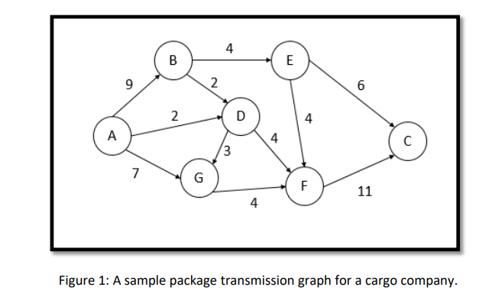

I